**Lab Exercise 4- Working with Docker Networking**

**Step 1: Understanding Docker Default Networks**

Docker provides three default networks:

* bridge: The default network when a container starts.
* host: Bypasses Docker’s network isolation and attaches the container directly to the host network.
* none: No networking is available for the container.

**1.1. Inspect Default Networks**

Check Docker's default networks using:

docker network ls

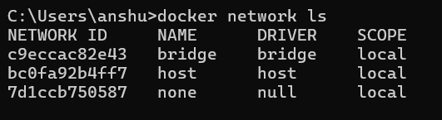

**1.2. Inspect the Bridge Network**

docker network inspect bridge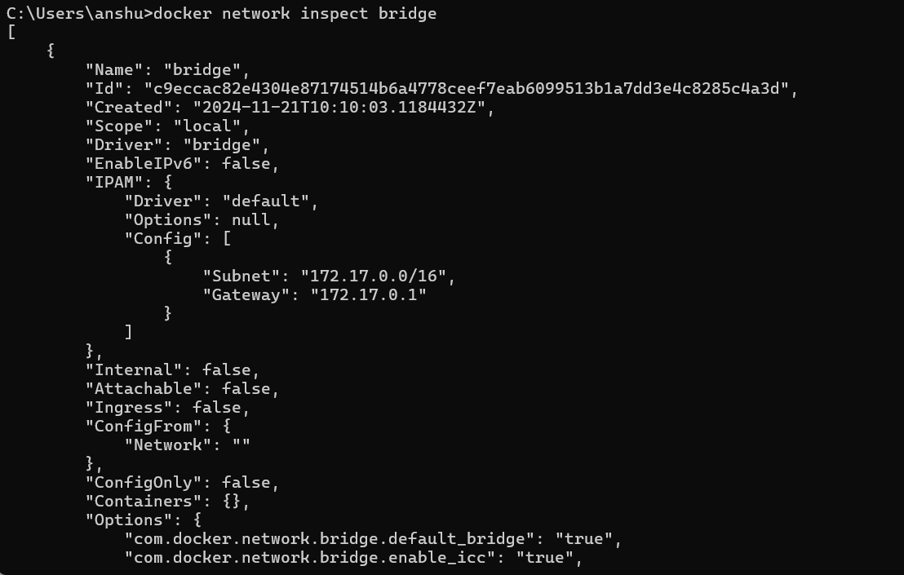This command will show detailed information about the bridge network, including the connected containers and IP address ranges.

**Step 2: Create and Use a Bridge Network**

**2.1. Create a User-Defined Bridge Network**

A user-defined bridge network allows containers to communicate by name instead of IP.

docker network create my_bridge

**2.2. Run Containers on the User-Defined Network**

Start two containers on the newly created my_bridge network:

docker run -dit --name container1 --network my_bridge busybox

docker run -dit --name container2 --network my_bridge busybox

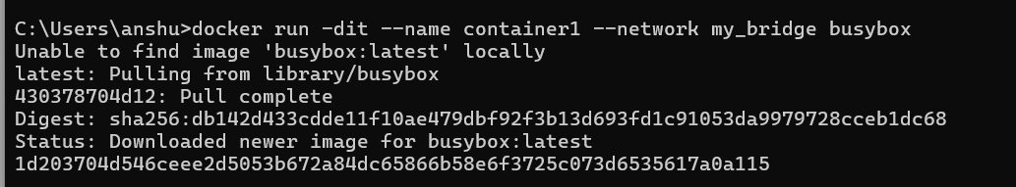



**2.3. Test Container Communication**

Execute a ping command from container1 to container2 using container names:

docker exec -it container1 ping container2

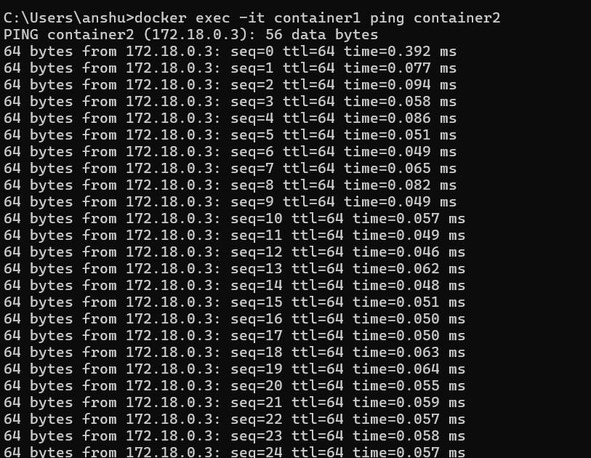The containers should be able to communicate since they are on the same network.

**Step 3: Create and Use a Host Network**

**3.1. Run a Container Using the Host Network**

The host network allows the container to use the host machine’s networking stack:

docker run -d --name host_network_container --network host nginx

Access the NGINX server via localhost:80 in your browser to verify the container is using the host network.

**3.2. Check Network**docker network inspect host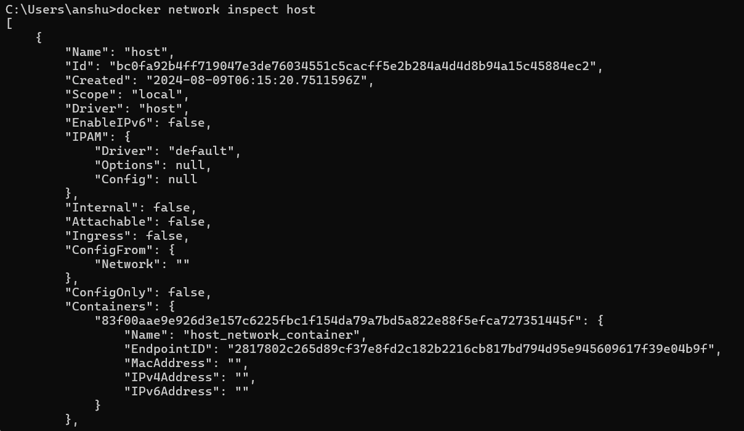**Step 4: Disconnect and Remove Networks**

**4.1. Disconnect Containers from Networks**

To disconnect container1 from my_bridge:

docker network disconnect my_bridge container1

**4.2. Remove Networks**

To remove the user-defined network:

docker network rm my_bridge

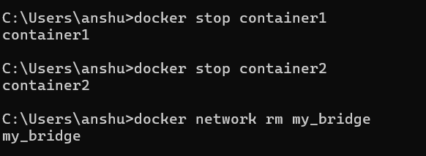

**Step 5: Clean Up**

Stop and remove all containers created during this exercise:

docker rm -f container1 container2 host_network_container

